Black Diamond Sales Order Processing Application Proposal

Abby hyne, mohammad islam, wally labarbera, Vianca Santana

2018

# **Requirements Document**

|  |  |
| --- | --- |
| Date Submitted: | April 4, 2018 |
| Application Title: | Black Diamond Sales Order Processing Application |
| Purpose: | This Windows application is used by employees to place customer orders with Black Diamond. They can enter customer information, shipping information, product information, and payment information. If needed, the user can view customer and product information stored in the server by Customer or Product ID. The cost of each individual product as well as the cost of the whole order is calculated for the employee. Each order is stored as a text document so that employees can reference the order as needed. |
| Program Procedures: | When entering and order, the employee has two options: they can manually enter customer information (generating a new Customer ID), or it can be automatically entered by using an existing Customer ID for customers that have placed orders with Black Diamond previously. Employees can then mark if the order is to be shipped, and if so, if it is to the customer's address or an alternative address. Next, the employee enters the product ID and quantity desired. Inventory is checked against a text document containing the current inventory status for each product to ensure the order can be filled. The application will then generate a price per product by referencing a text document containing the price per product and multiplying this price by the quantity entered. Finally, a summary form can be viewed containing the customer's information, shipping information, and the order information. A total cost is calculated by adding together the prices for each product, the shipping cost, and tax. At the bottom of the form, customer payment information is entered to finalize the order. The data generated by each form is stored in a text document for reference. |
| Algorithms, Processing, and Conditions: | 1. The Sale Order Processing Application displays the Black Diamond's logo and application title. 2. The employee selects a Customer ID from the drop-down menu, allowing the system to automatically fill in the customer's information, or manually enters the customer's information (first and last name, street address, province, state, postal code, country, email, and phone number), generating a new Customer ID. Customer information can be referenced in a separate form if needed. If the order is to be shipped to the customer, the employee places a check in a box. If the shipping address is the same as the customer's address, the employee places a check in another box; if not, the employee must manually enter the customer's shipping address information (customer name, street address, province, postal code, country, shipping instructions). 3. The employee then selects the Product Information button to enter the Product ID and quantity the customer desires to order. 4. The employee enters the Product ID of the product the customer wishes to order and the quantity. The application checks that product's availability against a text document containing inventory information. If it is available, the application calculates the price of the product by multiplying the quantity of the product by its price, located in another text document. If the product is not available, the quantity is invalid, or the Product ID or quantity is not selected, an error message is displayed. Product information can be viewed on a separate form if needed. 5. The employee then clicks the Payment and Confirmation button to review the order and enter payment information. 6. A summary of the customer's information and shipping information is displayed on the form. In addition, the form displays the product information, including the customer's total cost. This is done by adding together the price of each product in the order (a function of product price and quantity), adding the shipping cost($0.00 or $15.00), and multiplying this total by the 5% tax rate. 7. If the customer has their payment information saved, the employee can check the Use Saved Payment Info box, which references the customer information form to retrieve payment information. If the customer does not have payment information saved, the employee must enter it manually. The employee selects the payment type from a drop-down menu. The employee then enters the customer's card number, name on card, expiration date, and three-digit code. If the customer wishes to have their payment information saved, the employee can check the Save Payment Info box. 8. After all information is entered, the customer clicks the Submit Order button. The entire order summary is saved to a text document. |
| Notes and Restrictions: | 1. A Need Help? button is located at the top of the screen. If clicked, it gives the employee more information about the form and allows employees to reference the customer and information forms. 2. All input values are verified using Try-Catch blocks. Numeric values will be required for the postal code, telephone, order quantity, card number, expiration date, and three-digit code input boxes 3. There must be values in all input boxes with the exception of the shipping information boxes and payment information boxes. These boxes may be left blank if the customer is not having their order shipped (no check in the To Be Shipped box), their shipping address is the same as the address entered in Customer Information (Same As Customer box is checked), or their payment information is saved (Use Saved Payment Info box is checked). No null values will be excepted otherwise |
| Comments: | 1. When the program loads, it displays a splash screen for five seconds with the Black Diamond logo and application title. |

# Black Diamond Use Case Definition

1. A splash screen welcomes the user for approximately five seconds.
2. The user enters their Customer ID if they are a returning customer.
3. If they are a returning customer, the program automatically populates the information and billing section (on Payment Form).
4. The program offers the returning customer an opportunity to edit all area(s) of the customer information section.
5. The returning customer reviews the information for accuracy, makes the necessary edits, and then clicks the Product Entry button to continue with their purchase.
6. If the user is not a returning customer, the user is required to fill out the customer information section.The information section includes- First Name, Last Name, Street Address, Province, State, Postal Code, Country, Email, and Telephone.
7. After the customer information is complete, the user clicks the Product Entry Button.
8. Products and Quantity desired are then entered through combo/text boxes.
9. The system compares and ultimately verifies available inventory once the customer has selected the Product ID and Quantity desired.
10. If the Product ID and Quantity selected is unavailable, then a message box is displayed on the user’s screen. The message box states- “This product currently has (#) items available in stock. Please select a positive number that is less than or equal to the inventory on hand.”
11. The program opens a new Quantity box where the user can enter an updated Quantity number.
12. The user can place an order for up to six different products.
13. The program displays the respective Price Per Product, Shipping Cost, Tax Cost, and Total Cost for the Product IDs and Quantity selected.
14. If the user selects a valid Product ID, but fails to enter a valid Quantity number, a message box is displayed on the screen. The message box states “Error: Please enter a valid number for quantity”.
15. If the user does not select a Product ID, a message box will appear stating "Error: Please select a Product ID."
16. Once the user has entered both a valid Product ID and a valid Quantity number, the user clicks the Payment and Confirmation button.
17. The program verifies that the customer has entered the required information in the previous sections.
18. If the program finds that the customer has failed to enter the required information, the button will not be enabled.
19. The program displays the Order Summary Information that includes the Customer Information, Product Information, and Total Cost.
20. The user will then enter payment detail including payment type, name on card, expiration, card number and 3-digit code
21. Once the information in complete, the user clicks the Submit Order button to submit their order.
22. The transaction is recorded and updated in the system to reflect real-time inventory levels after the purchase has been made.
23. The user clicks the Submit Order button to exit the application.

# Sales Order Application GUI

## Customer & Shipping Information Form

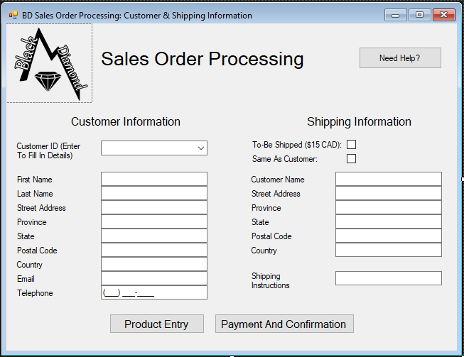

## Product Form

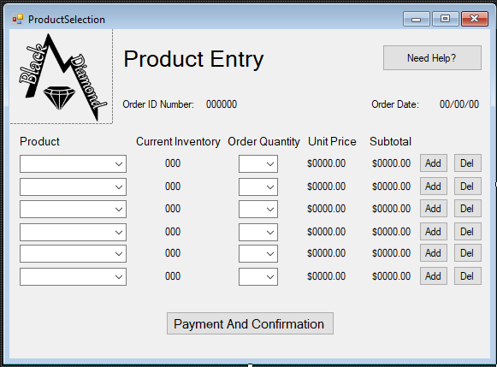

## Summary & Payment Form

